**OSI LAYER ARCHITECTURE**

**OSI:**

**OSI – O**pen **S**ystems **I**nterconnection. It was developed by ISO – International Organization for Standardization, in the year 1984. It is a 7 – layer architecture with each layer having specific functionality to perform. All these 7 layers work collaboratively to transmit the data from one person to another across the globe.

**OSI Model:**

The OSI model, created in 1984 by ISO, is a reference framework that explains the process of transmitting data between computers. It is divided into seven layers that work together to carry out specialised network functions, allowing for a more systematic approach to networking.

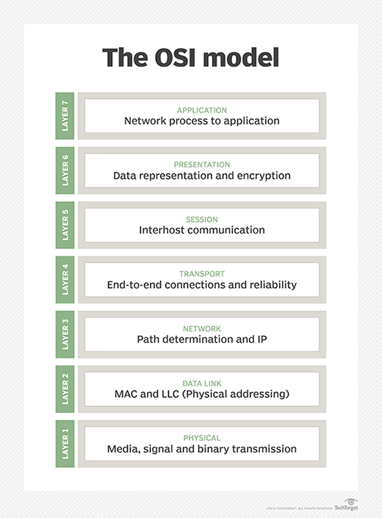

Figure: 1

**7 layers of the OSI model:**

1. Physical Layer
2. Data Link Layer
3. Network Layer
4. Transport Layer
5. Session Layer
6. Presentation Layer
7. Application Layer

**I)Physical Layer:**

The lowest layer of the OSI reference model is the physical layer. It is responsible for the actual physical connection between devices. The physical layer contains information in the form of bits. It is responsible for transmitting individual bits from one node to the next. When receiving data, this layer will get the signal received and convert it into 0s and 1s and send them to the Data Link Layer, which will put the frame back together.

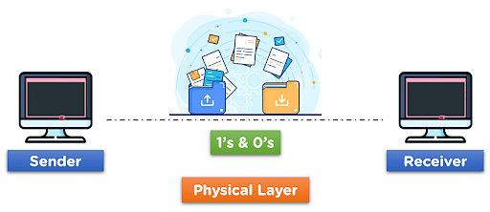

Figure: 2

**Functions of the Physical Layer:**

I)Bit synchronization

II)Bit rate control

III)Physical topologies

IV)Transmission mode

**Example:**

1. Hub, repeater, Modem and Cables are Physical Layer devices.

**Data Link Layer (DLL) – Layer 2:**

The data link layer is responsible for the node-to-node delivery of the message. The main function of this layer is to make sure data transfer us error-free from one node to another, over the physical layer. When a packet arrives in a network, it is the responsibility of the DLL to transmit it to the Host using its MAC address.

The Data Link Layer is divided into two sublayers:

1.Logical Link Control (LLC)

2.Media Access Control

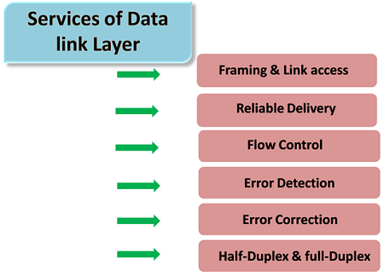

Figure: 3

**Functions:**

1) Framing

2) Physical addressing

3) Error control

4) Flow control

5) Access Control

**Key Points:**

I) Packet in the Data Link Layer is referred to as Frame.

II) Data Link Layer is handled by the NIC (Network Interface Card) and device drivers of host machines.

III) Switch & Bridge are Data Link Layer devices.

**Network Layer – Layer 3:**

The network layer works for the transmission of data from one host to the other located in different networks. It also responsible for packet routing i.e, selection of the shortest path to transmit the packet, from the number of routes available.

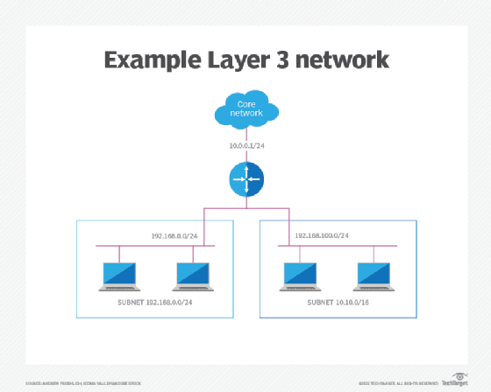

Figure: 4

**Functions:**

I) Routing

II) Logical Addressing

**Key Points:**

I) Segment in the network layer is referred to as Packet.

II) Network layer is implemented by networking devices such as routers and switches.

**Transport Layer – Layer 4:**

The transport layer provides services to the application layer and takes services from the network layer. The data in the transport layer is referred to as Segments. It is responsible for the End-to-End Delivery of the complete message. The transport layer also provides the acknowledgment of the successful data transmission and re-transmits the data if an error is found.

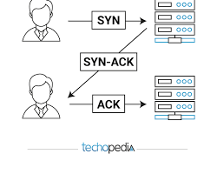

Figure: 5

**Functions:**

I) Segmentation and Reassembly

II) Service Point Addressing

**Services provided by Transport layer:**

1. Connection-Oriented Service

2. Connectionless Service

**Key Points:**

1) Data in the Transport layer is called Segments.

2) Transport layer is operated by the Operating System. It is a part of the OS and communicates with the Application Layer by making system calls.

3) The transport layer is called as Heart of the OSI model.

4) Device or Protocol Use: TCP, UDP, NetBIOS, PPTP

5)The sender needs to know the port number associated with the receiver’s application.

**Session Layer – Layer 5:**

This layer is responsible for the establishment of connection, maintenance of sessions and authentication and also ensures security.

Functions:

I) Session establishment, maintenance and termination

II) Synchronization

III) Dialog controller

**Key Points:**

I) Device or Protocol Use: NetBIOS, PPTP

**Presentation Layer – Layer 6:**

The presentation layer is also called the Translation Layer. The data from the application layer is extracted here and manipulated as per the required format to transmit over the network.

**Functions:**

I) Translation – For Example, ASCII to EBCDIC

II) Encryption / Decryption

III) Compression

**Key Points:**

Device or Protocol Use: JPEG. MPEG, GIF

**Application Layer – Layer 7:**

At the very top of the OSI Reference Model stack of layers, we find the Application layer which is implemented by the network applications. These applications produce the data, which has to be transferred over the network.

**Example:** Application – Browsers, Skype Messenger, etc

**Key Points:**

The application layer is also called Desktop layer.

Device or Protocol Use: SMTP.

**Functions:**

I) Network Virtual Terminal

II) FTAM- File Transfer access and management

III) Mail services

**Difference between TCP, UDP, ICMP:**

|  |  |  |  |  |  |
| --- | --- | --- | --- | --- | --- |
| Feature | TCP | UDP | ICMP |  |  |
| Layer | Transport Layer (Layer 4) | Transport Layer (Layer 4) | Network Layer (Layer 3) |  |  |
| Type | Connection-oriented | Connectionless | Error-reporting and diagnostic |  |  |
| Reliability | High | Low | Not applicable (not used for data transmission) |  |  |
| Ordering | Ensures packets arrive in order | No guarantee of order | Not applicable |  |  |
| Error checking | Yes, with retransmission of lost packets | No error checking | Yes, reports errors in IP communication |  |  |
| Congestion control | Yes, to avoid network overload | No congestion control | No congestion control |  |  |
| Handshake | Three-way handshake (SYN, SYN-ACK, ACK) | No handshake | Not applicable |  |  |
| Overhead | Higher due to connection setup and control | Lower due to simpler mechanism | Lower |  |  |
| Speed | Slower | Faster | Faster |  |  |
| Common uses | Web browsing, file transfers, email | Streaming media, gaming, VoIP | Ping, traceroute, network diagnostics |  |  |
| Port numbers | Uses well-known port numbers | Uses port numbers, but not as strictly defined | Doesn't use port numbers |  |  |
|  |  |  |  |  |  |

**Transport Layer Protocol and their port numbers:**

**TCP protocol:**

Common TCP Port Numbers:

* HTTP (Hypertext Transfer Protocol): 80
* HTTPS (Hypertext Transfer Protocol Secure): 443
* FTP (File Transfer Protocol): 21
* SMTP (Simple Mail Transfer Protocol): 25
* POP3 (Post Office Protocol version 3): 110
* IMAP (Internet Message Access Protocol): 143
* SSH (Secure Shell): 22
* Telnet: 23
* DNS (Domain Name System): 53
* MySQL database: 3306
* Microsoft SQL server: 1433

**User Datagram Protocol:**

Port Numbers:

* DNS (Domain Name System): 53
* DHCP (Dynamic Host Configuration Protocol): 67(server), 68(client)
* TFTP (Trivial File Transfer Protocol): 69
* SNMP (Simple Network Management Protocol): 161(Agent), 162 (Manager)
* Syslog: 514
* NTP (Network Time Protocol): 123

**Other Transport Layer Protocols:**

1) Real-Time Transport Protocol (RTP)

2) Stream Control Transmission Protocol (SCTP)